All new 11 loop, parameter

v, I = np.loadtxt("allnewloop11.data",usecols=[8,9],skiprows=5,unpack=True)

dm = 13.43

a= 0.003
a2 = -0.025

v=v+dm+0.12-0.04+a
I=I+dm+0.07+ a2

Fitting:

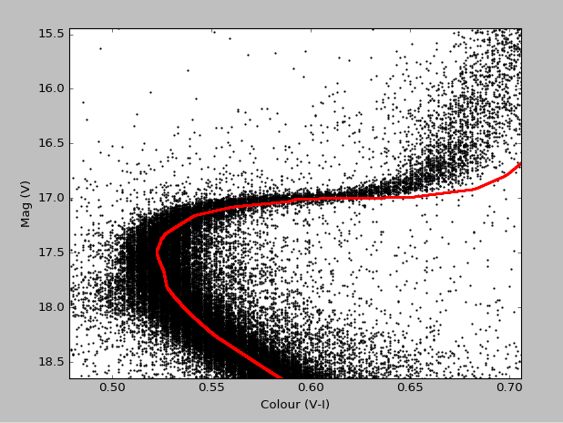

All new 12 loop:

dm = 13.43

a= -0.1
a2 = -0.12

v=v+dm+0.12-0.04+a
I=I+dm+0.07+ a2

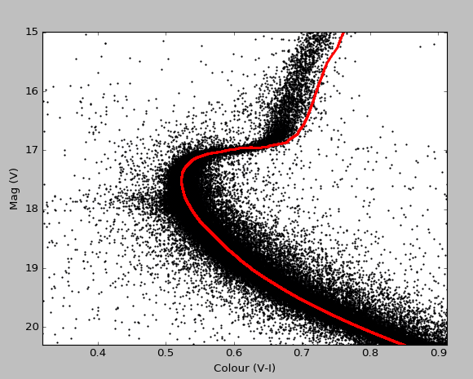

All new loop 13:

dm = 13.43

a= -0.15
a2 = -0.165

v=v+dm+0.12-0.04+a
I=I+dm+0.07+ a2

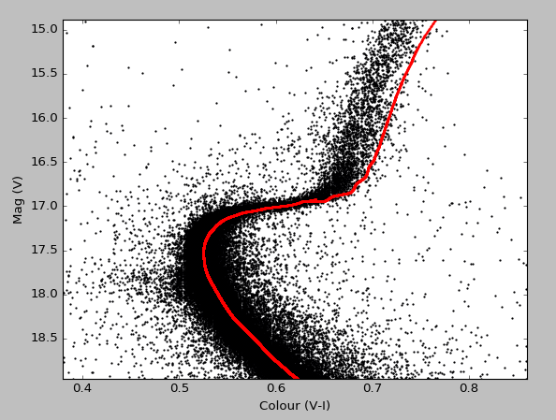

All new loop 09:

dm = 13.43

a= 0.13
a2 = 0.08

v=v+dm+0.12-0.04+a
I=I+dm+0.07+ a2

